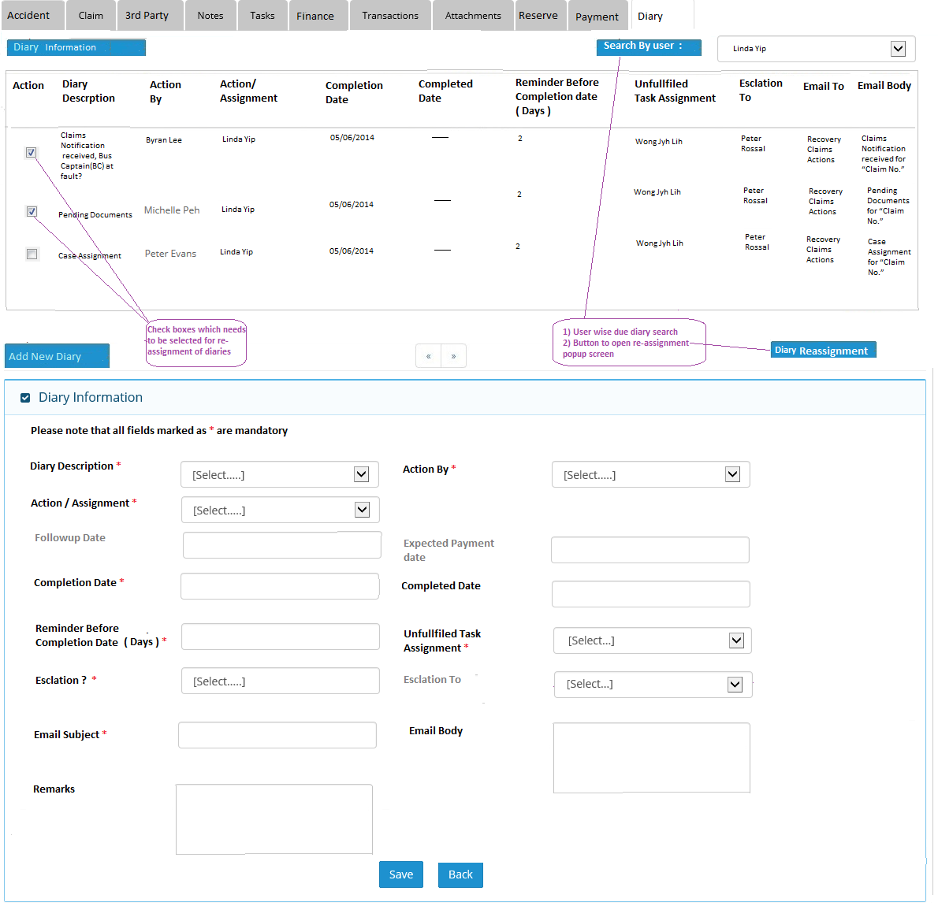

Note : After clicking on “Diary Re-assignment” button , following screen will be popup , by which user can reassign selected diaries.

